# CS 255 System Design Document Template

## UML Diagrams

### UML Use Case Diagram

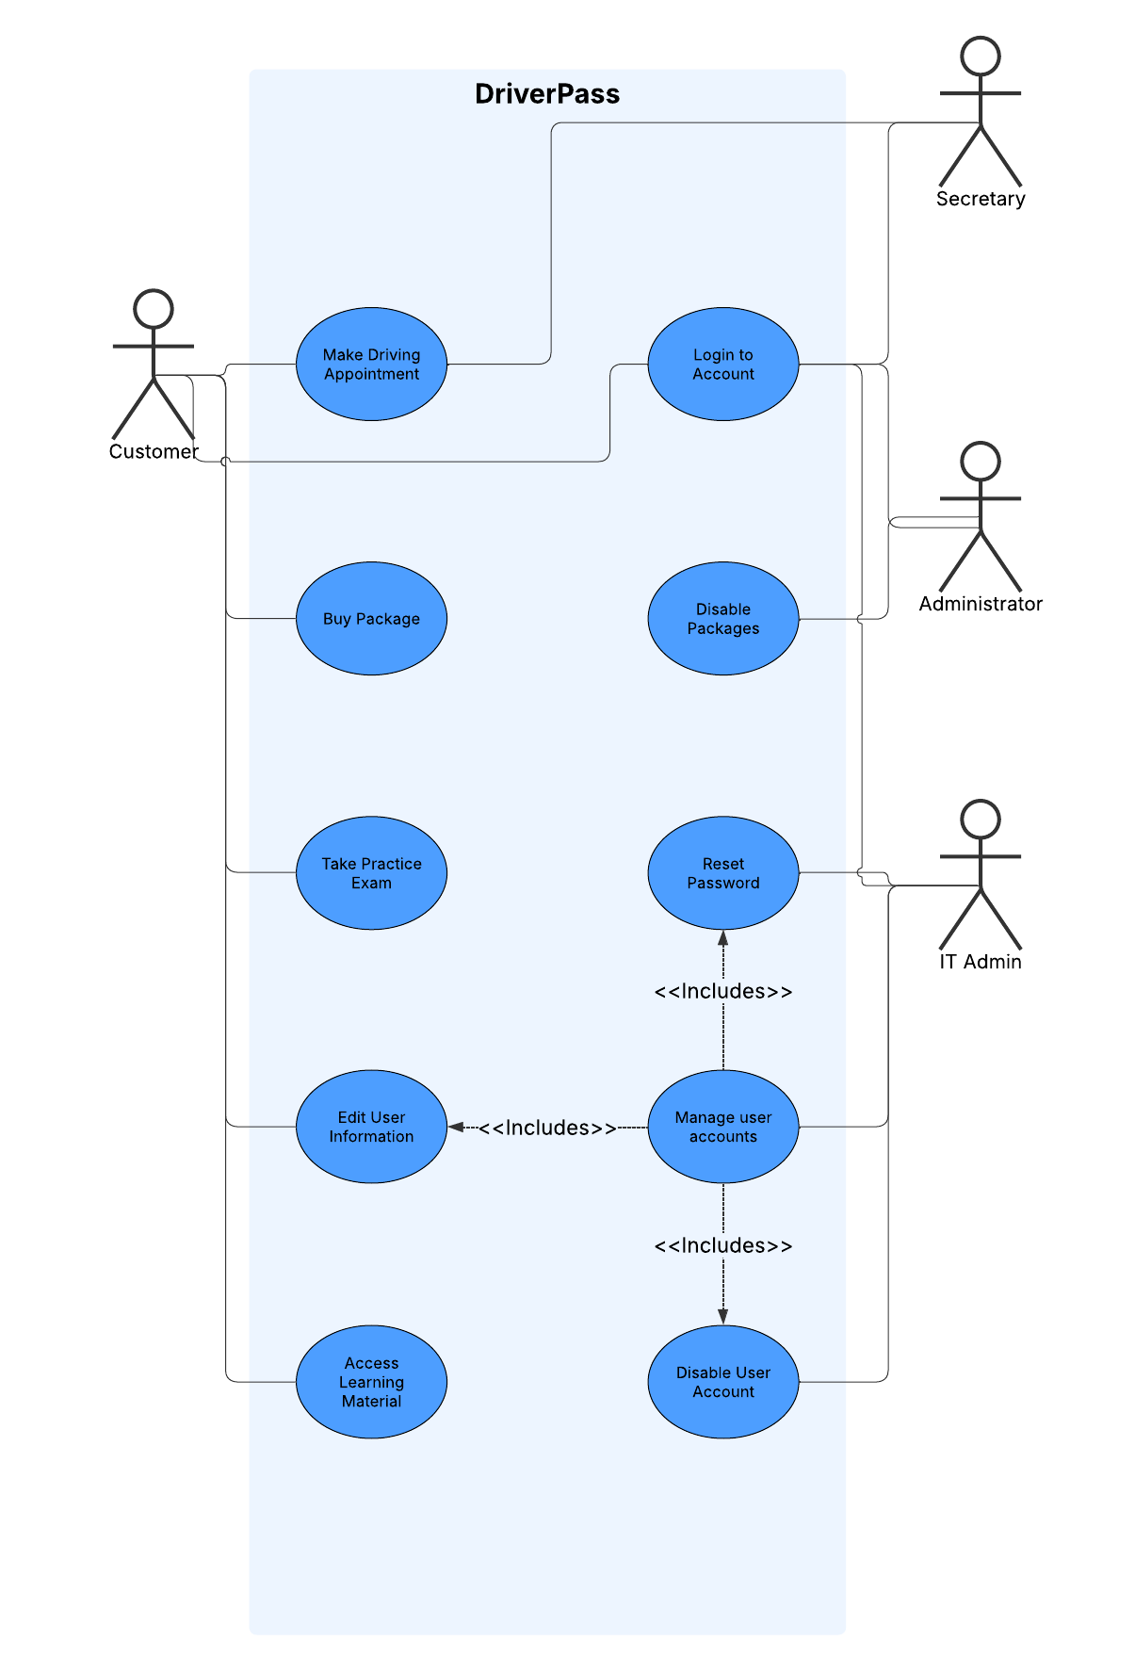

### UML Activity Diagrams

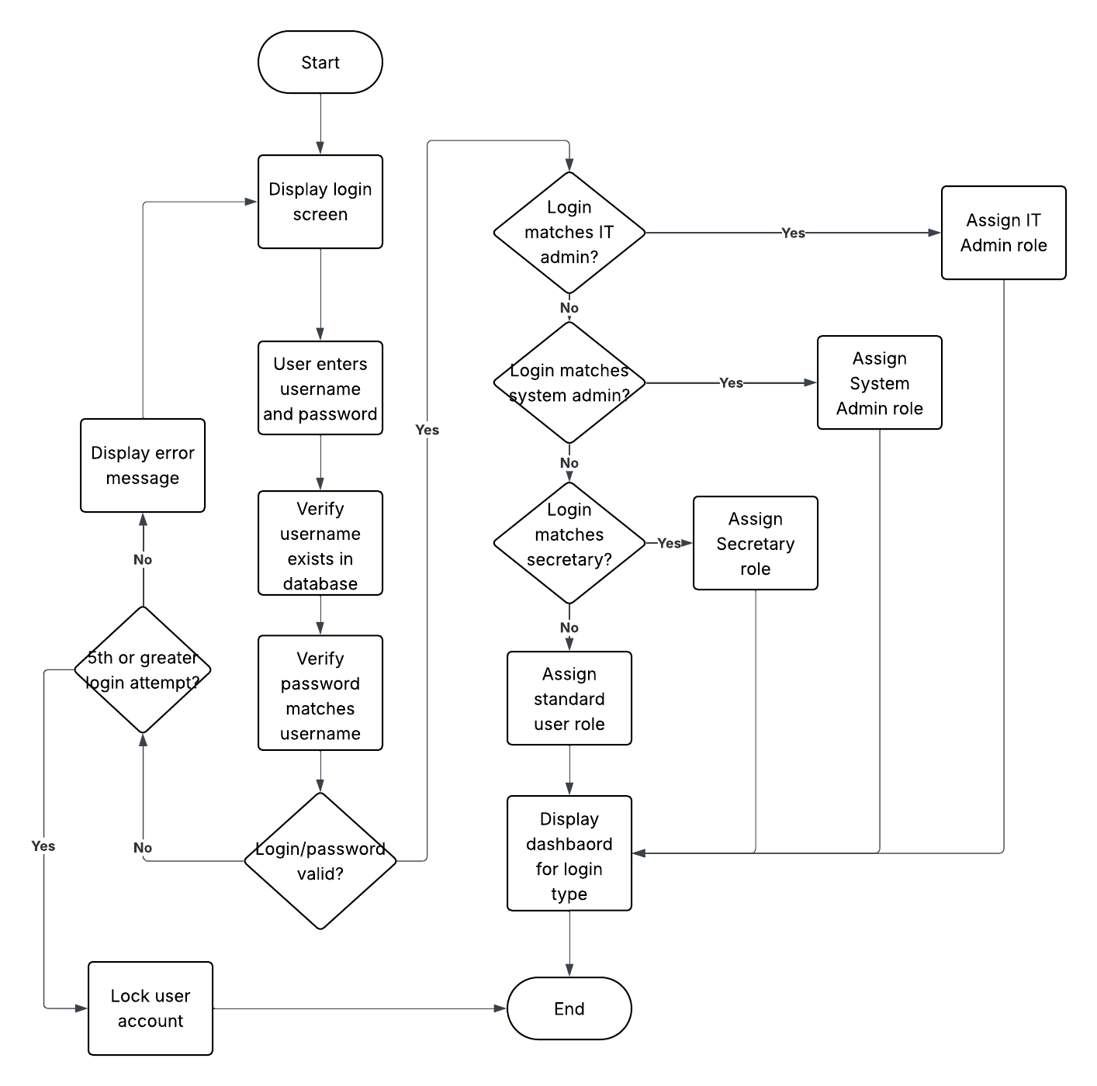

### 

**UML Sequence Diagram**

### 

### UML Class Diagram

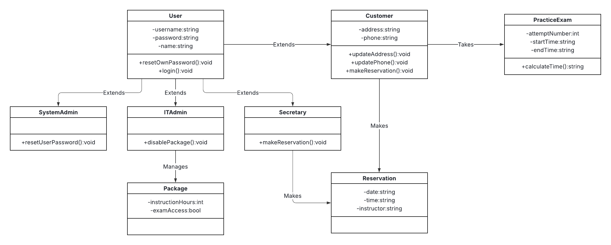

## Technical Requirements

* The system will be a cloud based system, running on commercially available vendor servers.
* We recommend using a windows-based server for this project, as it will provide the greatest familiarity and ease of use to system administrators.
* The system will be built using Java for the backend and Javascript w/ CSS for the front end, so a suitable cloud server must be found.
* No additional hardware will be needed on premise at DriverPass.
* The software will be developed by our company and run in all major web browsers across a variety of screen resolutions, including mobile devices.
* The chosen cloud vendor must have adequate security in place to protect user information as well as prevent corruption of system data.
* Data storage of the system should be great enough to handle the current amount of data from the DMV for driver information, as well as practice tests and any additional training materials.
* The system will begin with a modest user base but provide the option for scalability if/when the user base grows.